GSM BASED SMART ENERGY METER USING ARDUINO
A PROJECT REPORT
Submitted by
BARKAVI.V 421118105002
in partial fulfillment for the award of the degree
of
BACHELOR OF ENGINEERING
in
ELECTRICAL AND ELECTRONICS ENGINEERING
IFET COLLEGE OF ENGINEERING, VILLUPURAM.
ANNA UNIVERSITY::CHENNAI - 600 025
APRIL 2021

ANNA UNIVERSITY: CHENNAI 600 025
BONAFIDE CERTIFICATE

Certified that this project report “GSM BASED ENERGY METER USING ARDUINO” is the bonafide work of“BARKAVI.V (421118105002)” who carried out the project work under my supervision.

SIGNATURE SIGNATURE
Mrs.R.REVATHY,M.E Mr.T.RAMPRADESH, M.E (Ph.D.)
SUPERVISOR HEAD OF THE DEPARTMENT
Assistant Professor Associate Professor
Department of EEE, Department of EEE,
IFET College of Engineering, IFET College of Engineering,
Villupuram-605108. Villupuram-605108.

Submitted for the project viva voice examination held on ______________

INTERNAL EXAMINER EXTERNAL EXAMINER

ACKNOWLEDGEMENT
I thank profusely our Management of IFET COLLEGE OF ENGINEERING for providing me with the harmonious atmosphere, which is of utmost necessary for the project work.
I would like to express my graceful thanks to our Principal Dr.G.Mahendran, M.Tech (IITM), Ph.D., for providing me an opportunity to do the project.
I wish to express my extreme gratitude and heartfelt thanks to our Vice Principal and Dean Academics, Dr.S.Matilda, M.S., Ph.D., for extending the facilities available within the college campus.
I would like to articulate my profound gratitude to Dr.A.JohnDhanaseely,M.E.,Ph.D, Head-IFET Research Centre, Dr.P.Pugazhendiran, M.E., Ph.D, Controller of Examinations - IFETCE and Mr.T.RAMPRADESH, M.E.,(Ph.D) for their incitement and enthusiasm to make my project work wonderful and successful one.
I owe a deep debt of gratitude to my guide Mrs.R.REVATHY, M.E Assistant Professor of Electrical and Electronics Engineering for his proficient meticulous guidelines to consummate my project.
I wish to extend my deep sense of gratitude to my Faculty Advisor and Project Coordinators Mrs.R.Revathy Assistant Professor/EEE and Mr.T.RAMPRADESH, Associate Professor/EEE for their valuable suggestions and support in each and every stage of my endeavor in making my project work a success.
I would also like to express my gratitude to all theTeaching and Non-Teaching faculty members of the Department of Electrical and Electronics Engineering for their immense help throughout this project.
Finally, I convey my heartiest thanks to my Dear Parents, Friends and who encouraged and help me at different stages of this project with warm gestures.
~barkavi.v
ABSTRACT
The project aims to develop a GSM based energy meter reading system and load control through SMS. Electricity department sends employees to take meter reading every month, which is an expensive and time consuming job. The proposed project provides a convenient and efficient method to avoid this problem. The electricity department and the user can get the readings of the energy meter of consumers via SMS. The loads can also be controlled by the user of this system via SMS using this project. A microcontroller input is effectively interfaced to a digital energy meter that takes the reading from the energy meter and displays the same on an LCD. The reading of the energy meter is also sent to the control room by an SMS via SIM loaded GSM modem. This GSM modem can also receive commands from the cell phone to control the owner’s electrical loads. It uses a standard digital energy meter that delivers output pulses to the microcontroller to perform counting for necessary action. On receiving command it can switch ON/OFF the loads. This paper mainly focuses on the controlling of home appliances control system (HACS) and providing security.

TABLE OF CONTENTS
CHAPTER NO |  |  | TITLE | PAGE NO
 |  |  | ABSTRACT
 |  |  | LIST OF TABLES
 |  |  | LIST OF FIGURES
 |  |  | LIST OFABBREVIATION
1 |  |  | INTRODUCTION | 1
 | 1.1  1.2  1.3  1.4 |  | INTRODUCTION TO SMART METER  PROBLEM STATEMENT  OBJECTIVE  SCOPE OF THE PROJECT | 1  2  3  3
2 |  |  | LITERATURE REVIEW | 4
 | 2.1 |  | GSM BASED AUTOMATIC ENERGY METER READING SYSTEM WITH INSTANT BILLING | 4
 | 2.2  2.3 |  | SINGLE PHASE GSM BASED WIRELESS ENERGY METERING WITH USER NOTIFICATION SYSTEM  SMART ENERGY METERING WITH REALTIME POWER ANALYSIS AND AUTO MONTHLY BILLING | 5  5
 | 2.4  2.5 |  | GSM-BASED SMART ENERGY METER WITH ARDUINO UNO  DESIGN OF ENHANCED ENERGY METER USING GSM PREPAID SYSTEM AND PROTECTIVE RELAYS | 6  7
3 |  |  | SYSTEM ANALYSIS | 8
 | 3.1 |  | EXISTING SYSTEM | 8
 | 3.2 |  | PROPOSED SYSTEM | 10
 |  | 3.2.1 | ENERGY METER | 11
 | 3.3 | 3.2.2  3.2.3  3.2.4  3.2.5 | TYPES OF ENERGY METERS  ELECTRO MECHANICAL ENERGY METERS  ELECTRONIC ENERGY METERS  SMART ENERGY METER  TAMPERING OF ENERGY METER | 11  11  12  13  14
 | 3.4 |  | INTRODUCTION TO LTE NETWORK | 15
 | 3.5  3.6 |  | GSM800L NETWORK STRUCTURE  MESSAGING OVER GSM NETWORK | 16  16
4 | 4.1  4.2  4.3  4.4 |  | DESIGN AND IMPLEMENTATION  INTRODUCTION  SYSTEM DESCRIPTION  SYSTEM BLOCK DIAGRAM  DESIGN PROCEDURE | 17  17  17  18  18
5 | 4.5 | 4.4.1  4.4.2  4.4.3  4.4.4  4.4.5  4.4.6  4.4.7  4.4.8  4.4.9  4.4.10  4.4.11 | CIRCUIT ANALYSIS  POWER SUPPLY  TRANSFORMER  RECTIFIER  REGULATOR POWER SUPPLY  LCD  RELAY  RELAY DRIVER  8051 SERIES MICROCONTROLLER  THE MAX 232 IC  HARDWARE DESIGN  HARDWARE OUTPUT  CONCLUSION  REFERENCE | 18  19  20  21  22  22  24  25  26  31  32  32  33  34
 |  |  | LIST OF FIGURE
FIGURE NO |  |  | TITLE | PAGE NO
1.1 |  |  | POWER BILL | 1
1.2  3.1  3.2.2.1  3.2.2.2  3.2.2.3  3.5  4.3  4.4.1  4.4.2  4.4.4  4.4.5  4.4.6  4.4.7  4.4.10 |  |  | SMART METERS MARKET  BLOCK DIAGRAM OF EXISTING SYSTEM  ELECTROMECHANICAL INDUCTION TYPEENERGY METER  ELECTRONIC ENERGY METER  SMART ENERGY METER  LTE NETWORK STRUCTURE  BLOCK DIAGRAM OF PROPOSED SYSTEM  CIRCUIT DIAGRAM  BLOCK DIAGRAM OF POWER SUPPLY  RECTIFIER  REGULATED POWER SUPPLY  LCD MODULE  RELAY  MAX232 | 2  9  11  12  13  16  18  18  19  21  22  23  24  26
LIST OF TABLES
TABLE NO TITLE PAGE NO
4.4.9 EXTERNAL DATA MEMORY 28

LIST OF ABBREVIATION
HACS-Home Appliances Control system
SEM – Smart Energy Meter

CHAPTER 1
INTRODUCTION TO SMART METER
1.1 INTRODUCTION
Today, humanity can be classified as living in a “Machine society” where technological tools are predominantly at different levels, interfacing in the day-to-day activity of man. Electricity is one of the vital requirements for sustainment of comforts of life and so it should be used very judiciously for its proper utilization. It has become a trend to integrate automatic systems via wireless applications over network. Along with the advancement of technology development, research on wireless applications and remote control has become significant and popular today. An electricity meter, electric meter, or energy meter is a device that measures the amount of electric energy consumed by a residence, business, or an electrically powered device. These electricity consumption meters are generally called as energy meter.
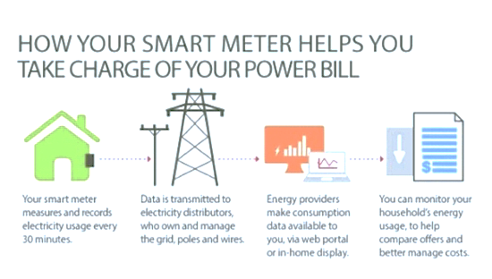Fig.1.1 Power Bill
A smart energy meter (SEM) is electronic device having energy meter chip for electric energy consumed measurement, wireless protocol for data communication
(such as LTE) and peripheral devices for security purpose, data showing, meter controlling etc. The meter which is used for measuring the energy utilizes by the electric load is known as the energy meter. It is used in domestic and industrial AC circuit for measuring the power consumption. The prepaid meter is important in making the consumer having sense about his or her energy consumption as well as in resolving the issues facing by the utility labor in gettingThe reading of conventional meter and eliminating the error incurred in bills issuing. The meter is less expensive and accurate.
1.2 PROBLEM STATEMENT
The current electricity billing system is completely manual. The energy meter reading is collected by meter reader on their fortnightly or monthly visits to the premises. In conventional metering system to measure electricity consumption the energy provider company hires persons to visit each house and record meter reading manually which is used for billing, the bill then sent to consumer by post or hand delivery, this is not only sluggish but laborious, with the company having no control over these meters. There is a stark amount of revenue loss being incurred by our country due to energy theft which is a serious problem, people try to manipulate meter reading by adopting various corrupt practices such as current reversal, partial earth fault condition, bypass meter, magnetic interference etc. with the aid of this project a definite solution is preferred which allows power companies to have total control over energy meter and have real time information of same from a remote location with little human effort and at reduced cost as compared to conventional methods.

1.3 OBJECTIVE
The purpose of this project is the remote monitoring and control of the domestic energy meter. It reads reading from an energy meter, display that reading on the LCD panel. To provide automated load energy reading over an immediate basis.To resolve the issues facing by the utility labor in getting the reading of conventional meter and eliminating the error incurred in bills issuing. Different hardware and software have been used in this project. The prepaid system, monitoring and record data that too is online accessible.
1.4 SCOPE OF THE PROJECT
The scope of this project is to design and construct LTE based a one phase two wire energy meter with voltage rating of 220V, current of 25 – 100A operating at 50Hz and interfaced with microcontroller unit and LTE module with a LCD with wireless communication feature over SMS. Within the scope of this project, the prototype model is equipped with a dedicated SIM (Subscriber Identification Module).
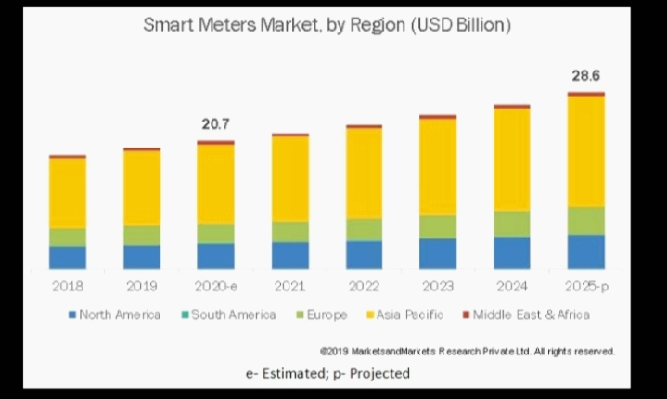
Fig.1.2Smart Meters Market, by Region(USD Billion).

CHAPTER 2
LITERATURE SURVEY
2.1 GSM BASED AUTOMATIC ENERGY METER READING SYSTEM WITH INSTANT BILLING
The technology of e-metering (Electronic Metering) has gone through rapid technological advancements and there is increased demand for a reliable and efficient Automatic Meter Reading (AMR) system. This paper presents the design of a simple low cost wireless GSM energy meter and its associated web interface, for automating billing and managing the collected data globally. The proposed system replaces traditional meter reading methods and enables remote access of existing energy meter by the energy provider. Also they can monitor the meter readings regularly without the person visiting each house. A GSM based wireless communication module is integrated with electronic energy meter of each entity to have remote access over the usage of electricity. A PC with a GSM receiver at the other end, which contains the database acts as the billing point. Live meter reading from the GSM enabled energy meter is sent back to this billing point periodically and these details are updated in a central database. A new interactive, user friendly graphical user interface is developed using Microsoft visual studio .NET framework and C#. With proper authentication, users can access the developed web page details from anywhere in the world. The complete monthly usage and due bill is messaged back to the customer after processing these data.
2.2 SINGLE PHASE GSM BASED WIRELESS ENERGY METERING WITH USER NOTIFICATION SYSTEM
The automation is now becoming necessary almost in every field including distribution, control and monitoring of electrical energy. However, in Pakistan the situation is very poor, and the country is facing the severe energy crisis because of outdated power system infrastructure. Even the energy monitoring and metering system for billing is still based on conventional electro-mechanical type meters; which are now being replaced by electronic type digital energy meters. However, the collection of energy meter readings data from these meters is being conducted manually which opens the doors of corruption in the form of overbilling which is a major challenge for the current government together with the electricity theft. Although some steps, including the deployment of mobile based meter reading process using android phones, have been taken to solve this issue but the problem still persists. This is mainly because of the traditional manual meter reading method, which is obsolete, outmoded, inefficient and time consuming. So, this paper presents the simple, efficient, and inexpensive design of an automatic single phase energy meter reading system based on GSM wireless network which also has the provision for user notification.
2.3 SMART ENERGY METERING WITH REALTIME POWER ANALYSIS AND AUTO MONTHLY BILLING
The GSM module requires a SIM (Subscriber Identity Module) card just like mobile phones to activate communication with the network. Direct current (DC) components are used to control alternating current (AC) loads. Meter readers don’t need to visit each customer for the consumed energy data collection and to distribute the bill slips. Microcontroller can be used to monitor and record the meter reading. In case of a customer defaulter,no need to send a person of utility to cut-off and reconnect the customer connection by short message service(SMS). Furthermore, the customer can check the status of electricity (load) from anywhere. There are many problems in metering and billing processes like going of meter reader to each customer meter to manually take the meter reading, the probability of the non-existence of the customers at their houses during that time, the lack of integrity and credibility of some of the meter readers, the safety and the outback represent a huge drawback cannot be neglected. In this system energy meter readings are being transferred by making use of GSM.
2.4 GSM BASED SMART ENERGY METER ARDUINO UNO
This paper proposed and demonstrated Smart Energy Meter that the users will be able to monitor their current power consumptions (bill) anytime from anywhere by using their mobile phone via Short Message Services (SMS). It would be a huge beneficial for the customers if they can monitor their energy meter’s power consumptions (bill) on a real—time basis. Arduino UNO, main controller, was the interface between energy meter and Global System for Mobile Communication (GSM) module. The Arduino takes the pulse from the energy meter, calculate units and displays the reading on the LCD. GSM module connects the energy meter to user’s mobile phone. Real Time Clock (RTC) DS1307 was used to get the real time to count and store the usage into the EEPROM. The program developed in C language with the Arduino syntax in the Arduino IDE. An Arduino bad smart metering system comprising of a smart energy meter and a mobile phone acting as a central server receiving all the data sent by the energy meter. The proposed system demonstrated its capability to check the current usage (bill), notify when reaching the limit, and reset the usage (bill) successfully, only via accessing GSM- based mobile phone. Energy meter billing is an important part of energy distribution [1]. The use of manual systems is undesirable. Due to human errors at utility companies, it is a problem for users to get them corrected; that is, customers have to stopover at the company offices, stand in a queue and get it corrected. There is a need to improve the accuracy of the bills. To avoid human
2.5 DESIGN OF ENHANCED ENERGY METER USING GSM PREPAID SYSTEM AND PROTECTIVE RELAYS
Technology has developed to an advanced level so customer demands for systems with automation and high security. The prepaid meter is important in making the consumer having sense about his or her energy consumption as well as in resolving the issues facing by the utility labor in getting the reading of conventional meter and eliminating the error incurred in bills issuing. This research aims to enhance an existing conventional energy meter integrate with prepaid system and protection system. The designed prepaid meter consists of an Arduino, conventional energy meter, GSM (Global System for Mobile Communications) module, current sensor and relay. The proposed prototype comprises into two Parts: GSM technology and over current protection, whereas GSM technology is used for communication and reloads purpose; over current protection is done with a current sensor and relay working together. The prepaid meter is important in making the consumer having sense about his or her energy consumption as well as in resolving the issues facing by the utility labor in getting the reading of conventional meter and eliminating the error incurred in bills issuing. The accuracy and resolution of the energy meter have improved significantly in the past few years.

CHAPTER-3
SYSTEM ANALYSIS
3.1 EXISTING SYSTEM
In Existing system, Analysis can be done by using GSM module while using GSM Billing system fails if no GSM Network coverage. Most of the residence used a fuse as protective equipment which has some disadvantages.It requires fixed GSM number and charges may be applicable for network use. Compare with LTE,GSM multiple users share the same bandwidth. It provides limited data rate capability. In order to increase the coverage repeater are required to be installed. The conventional meter reading system has its own shortcomings and a lot of nuisances; because of the outdated plans implemented by the state electricity supply company in energy management systems which causing both energy suppliers and energy consumers to face many problems. The electrical bill is recorded by the bill collectors sent by the utility company.
Power system protection played an important role in the powersystem. Power system protection protects the power system from faults by isolating faulty components from other components. There are various types of protection equipment existed in the market including circuit breakers, instrument transformer, fuses, protectiverelays and so on. It is extremely important and a must forall the residence to install the fuse and circuit breaker to protect equipment from failures, prevent on fire and simple wiring problem.Most of the residence used a fuse as protective equipmentwhich has some disadvantages when compared with the protective relay. The need to replace the fuse after each failure is a waste oftime and cost. A fuse can be replaced by a relay, used to controlthe flow line of electricity. By controlling the flow of current through the electromechanical circuitry, relays can be used to switch circuits and activate or deactivate many of the circuits connected to them without having manually used the switching circuits.Currently there is no system to give intimation to mobile phones and to monitor the energy levels in industries, houses,hospitals etc.,presently we were using the manual monitoring and intimating methods to monitor the energy levels in industries, houses,hospitals etc.
Fig. 3.1.Block diagram of Existing system
The functional block diagram of the GSM-based prepaid energy meter is illustrated in Fig.3.1 as above. AC current, which is the main power source, flows directly into the electric energy meter. The energy unit is calibrated by pulse blink technique by using optocoupler IC counting and redirect the pulse to the Arduino microcontroller. The LCD display is connected to the main brain – Arduino, to display the messages and credit balance. GSM module is used to send and receive SMS, either sending alert or notification message or receive recharge code. Therelay is connected to the watt-hour meter with Arduino as the input and load as the output to control the load ON / OFF. The current sensor continuously measures the current flow to ensure optimal and stable current flow to the load. If any excessive current detected, the relay immediately reacts to prevent electricityflow. This can prevent the load from failure and burn due to the overcurrent.
3.2 PROPOSED SYSTEM
LTE based smart energy meters for advanced metering and billing system is able to read and send data via wireless protocol using LTE technology through LTE modem, capable of managing the meters as well as the line connections.A fuse can be replaced by a relay, used to control the flow line of electricity.Compared with previous mobile network technologies, LTE offers much higher bandwidth, lower latency and improved spectrum efficiency. In telecommunication, Long Term Evolution is a standard for wireless broadband communication for mobile devices and data terminals, based on the GSM/EDGE and UMTS/HSPA technologies. The high level network architecture of LTE is comprised of following three main components:
- The User Equipment (UE)
- The Evolved UMTS Terrestrial Radio Access Network(E-UTRAN)
- The Evolved Packet Core(EPC)

3.2.1 ENERGY METER
An electricity meter or energy meter is a device which measures the amount of electric energy consumed by a residence, business, or an electrically powered device. The meter which is used for measuring the energy utilizes by the electric load is known as the energy meter. The energy is the total power consumed and utilized by the load ata particular interval of time. It is used in domestic and industrial AC circuit for measuring the power consumption. The meter is less expensive and accurate. Electricity meter are typically calibrated in billing units, the most common one being the kilowatt hour [kWh]. Periodic reading of electricity meters establishes billing cycles and energy used during a cycle.
The most common unit of measure on the electricity meter is the kilowatt hour [kWh], which is equal to the amount of energy used by a load of one kilowatt over a period of one hour, or 3,600,000 joules. Some electricity companies use the SI mega joule instead. Demand is normally measured in watts, but averaged over a period, most often a quarter or half hour.Reactive power is measured in ‘‘thousand of volt-ampere reactive-hour’’, (kvarh), by convention, a ‘‘lagging’’ or inductive load, such as a motor, will have positive reactive power. A ‘‘leading’’ or capacitive load, will have negative reactive power.
3.2.2 TYPES OF ENERGY METER
Electricity meters operate by continuously measuring the instantaneous voltage and current to give energy used(in joules, kilowatt-hours etc.).
3.2.2.1ELECTRO MECHANICAL INDUCTION TYPE ENERGY METER
The most commonly used electricity meter is the electromechanical induction meter. The basic working of single phase induction type energy meter is focused on two mechanisms: It consists of rotation aluminum disc mounted on a spindle between two electro magnets. This meter operates by counting the number of revolutions of an aluminum disc. The moving element has no electrical contact with the circuit. Electromechanical induction type energy meter are universally used for energy measurements in homes and industries. They are cheap to manufacture and very accurate. A major problem with these types of meters is their easy prone to tempering, leading to a requirement of an electrical energy monitoring system. They have high torque is to weight ratio as compared to other instruments.
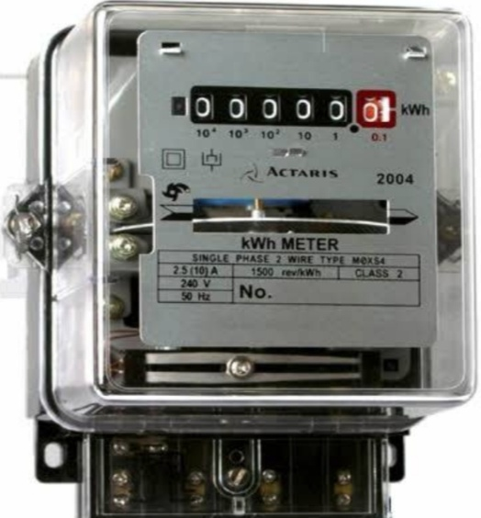
Fig 3.2.2.1 Electro Mechanical Induction Type Energy Meter
3.2.2.2 ELECTRONIC ENERGY METER
Electronic Energy Meter is based on digital Micro technology (DMT) and uses no moving parts. So the electronics energy meter is known as Static Energy meter. In Electronic Energy meter the accurate functioning is controlled by a specifically designed IC called Application specified integrated circuit (ASIC). ASIC is constructed only for specific applications using embedded system technology. In additional to ASIC, analogue circuit, voltage transformer, current transformer etc. are also present in electronic energy meter to sample current and voltage. It has better accuracy. The electronics energy meter is also better protection against tampering than its mechanical predecessor, and units for prepaid operation (e.g., Card Reader) and remote meter reading (e.g., wireless, telephone line, or internet) can easily be included.
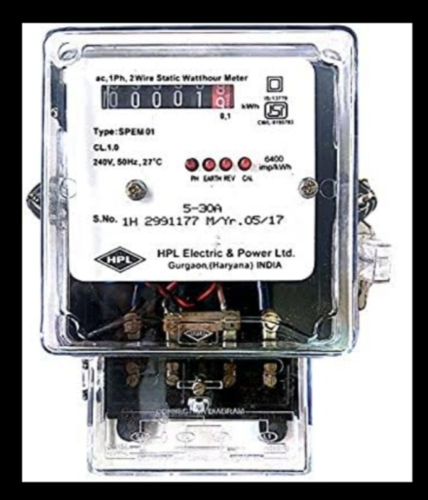
Fig 3.2.2.2 Electronic Energy Meter
3.2.2.3 SMART ENERGY METER
A smart meter is an electronic device that records information such as consumption of electric energy, voltage levels, current, and power factor. It is an advanced metering technology involving placing intelligent Meyers to read, process and feedback the data to customers. It measure energy consumption, remotely switching the supply to customers and remotely controls the maximum electricity consumption. Smart metering system uses the advanced metering infrastructure system technology for better performance. These are capable of communicating in both directions. These meters reduce the need to visit while taking or reading monthly bill. They can transmit the data to the utilities like energy consumption, parameter values, alarms, etc. and also can receive information from utilities such as automatic meter reading system, reconnected\disconnected instruction, upgrading of meter software’s and other important message.
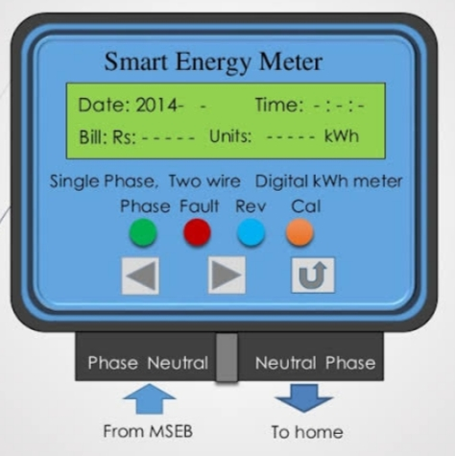
Fig 3.2.2.3Smart Energy Meter
3.3 TAMPERING OF ENERGY METER
To control revenue losses, utility companies worldwide need to detect meter tampering and ensure accurate billing even when tampering has occurred. Tampering may range from simple techniques like manipulating live or neutral wires to more sophisticated ones like hacking firmware and changing energy consumption records.Meter tampering means doing any act which causes the meter to run slower or not at all and sis basically theft of electricity from the company that supplies power. Meter tampering in the broadest sense is an illegal method employed by consumers to gain entry, break in, or some cases break the meter to deplete key functionalities, with the goal of reducing or completely eliminating the cost of energy usage.
3.4 INTRODUCTION TO LTE NETWORK
LTE stand for Long Term Evolution and it was started as a project in 2004 by telecommunication body known as the Third Generation Partnership Project (3GPP). SAE (System Architecture Evolution) is the corresponding evolution of the GPRS/3G packet core network evolution. The term LTE is typically used to represent both LTE and SAE. LTE evolved from an earlier 3GPP system known as the Universal Mobile Telecommunication System (UMTS), which in turn evolved from the Global System for Mobile Communications (GSM).LTE is the successor technology not only of UMTS but also of CMDA 2000. It is an ideal technology to support high date rates for the service such as voice over IP (VOIP), streaming multimedia, videoconferencing or even a high- speed cellular modem. It has some advantages:
HIGH THROUGHPUT: High data rates can be achieved in both downlink as well as uplink. This causes high throughput.
LOW LATENCY:Time required to connect to the network is in range of a few hundred milliseconds and power saving states can be entered and exited very quickly.
FDD AND TDD IN THE SAME PLATFORM: Frequency Division Duplex and Time Division Duplex, both schemes can be used on same platform.
SUPERIOR END-USER EXPERIENCE: Optimized signaling for connection establishment and other air interface and mobility management procedures have further improved the user experience.
3.5 GSM800L NETWORK STRUCTURE
A standard LTE system architecture consists of an Evolved UMTS Terrestrial Radio Access Network, more commonly known as E-UTRAN, and the system Architecture Evolution, also known as SAE. SAE’s main component is the Evolved packet core, also known as an EPC. The E-UTRAN is comprised of: User Equipment (UEs).
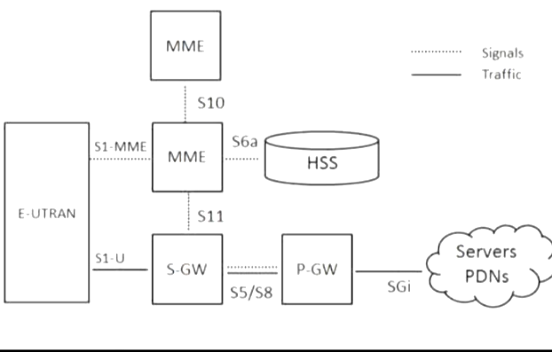
Fig 3.5LTE Network Structure
3.6 MESSAGE OVER GSM MODEM NETWORK
In LTE (packet-based all-IP) network, the circuit switched SMS service is handled adopting circuit switched fall-back (CSFB) technology. So, when an LTE device is used to place a voice call or send SMS, the device ‘‘falls back’’ to the 3G or 2G network over SGs interface to complete the call or to deliver the SMS.LTE and EPS will support a rich variety of messaging applications and also SMS is supported over LTE. The solution is twofold, covering both full IMS case and a transition solution for those networks that do not support IMS. SMS over IP was fully specified 3GPP Rel7.
CHAPTER-4
DESIGN AND IMPLEMENTATION
4.1 INTRODUCTION
This chapter entails the design and implementation procedure of the LTE energy meter detailing step by step the theoretical analysis, choice of components. The design procedure is divided into hardware and software design as discussed below.
4.2 SYSTEM DESCRIPTION
The LTE Based Energy Meter is an electronic unit design to take real time energy usage using a current sensing method which is then communicated to a microcontroller, who takes the appropriate calculations and displays on an LCD. LTE modems have a connection interface, allowing it to be connected to any device. The parameters to be monitored
- Units of a month
- Bill of a months
- Real(TRUE) power
- Load on a line
- Last unit details

LTE based smart energy meters for advanced metering and billing system is able to read and send data via wireless protocol using LTE technology through LTE modem, capable of managing the meters as well as the line connections.LTE network to enable high-speed,high-performance smart grid applications that deliver broad territory coverage, low latency.

4.3 SYSTEM BLOCK DIAGRAM

Transformer
Regulator
Rectifier
Load
Relay
Driver
Display
Re
l a y s
Interface
8051 series MC
ASM/C Program
Energy Meter
DB9
MAX232
LTE modem
AcSource

Fig 4.3 Block Diagram
4.4 DESIGN PROCEDURE
4.4.1 CIRCUIT ANALYSIS

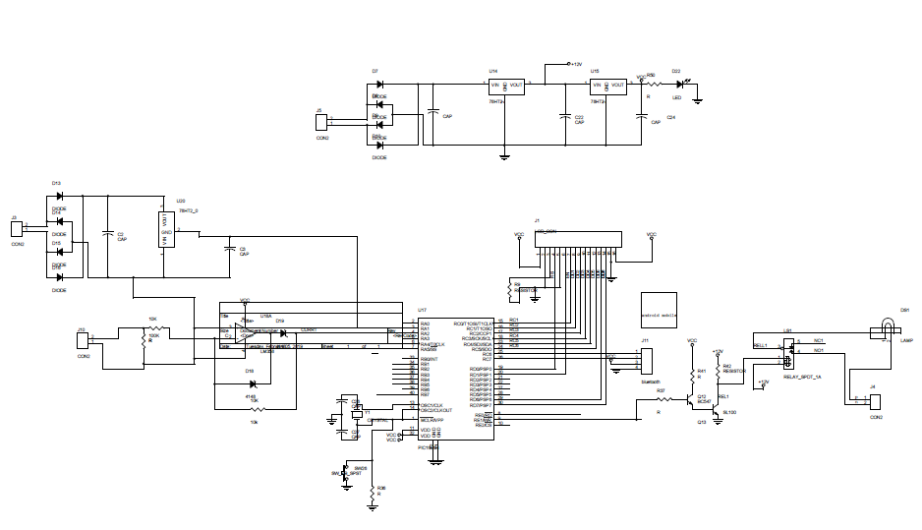
Fig 4.4.2 Circuit Diagram
In our project,we are using 8051 microcontrollerto get the input from current transformer and potential transformer. Here current transformer output will be in mill volt range. For converting this we use precision rectifier. Its output is given to microcontroller. And the potential transformer output is given to bridge rectifier circuit for getting the required voltage. After getting the voltage and current, we can calculate the power. And then we are monitoring this power,the amount of power utilized will have been displayed on LCD display. Also LTE MODEM will give intimations of the energy meter reading to the consumer
4.2POWER SUPPLY
We are using linear regulated power supply having 5V output which will be useful for driving the other components in the circuit like microcontroller. The ground terminal of the power supply must be isolated properly so that no voltage is induced in it.

Types of Power Supply:

There are many types of power supply. Most are designed to convert high voltage AC mains electricity to a suitable low voltage supply for electronic circuits and other devices. A power supply can by broken down into a series of blocks, each of which performs a particular function.
For example a 5V regulated supply:
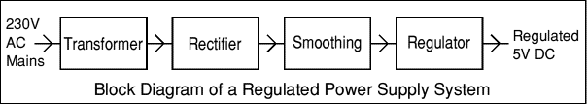
Fig 4.4.2 Block Diagram of a power supply
Each of the blocks is described in more detail below:
- Transformer - steps down high voltage AC mains to low voltage AC.
- Rectifier - converts AC to DC, but the DC output is varying.
- Smoothing - smooths the DC from varying greatly to a small ripple.
- Regulator - eliminates ripple by setting DC output to a fixed voltage.
4.4.3 TRANSFORMER
A transformer is defined as a passive electrical device that transfers electrical energy from one circuit to another through the process of electromagnetic induction.Transformers convert AC electricity from one voltage to another with little loss of power. Transformers work only with AC and this is one of the reasons why mains electricity is AC.Step-up transformers increase voltage, step-down transformers reduce voltage. Most power supplies use a step-down transformer to reduce the dangerously high mains voltage (230V in UK) to a safer low voltage. The input coil is called the primary and the output coil is called the secondary. There is no electrical connection between the two coils; instead they are linked by an alternating magnetic field created in the soft-iron core of the transformer. The two lines in the middle of the circuit symbol represent the core. Transformers waste very little power so the power out is (almost) equal to the power in. Note that as voltage is stepped down current is stepped up. The ratio of the number of turns on each coil, called the turns ratio.
Turns ratio = | V p | = | N p | and | power out = power in
Turns ratio = | Vs | = | Ns | and | Vs × Is = V p × I p
Change this and type it

Vs= secondary (output) voltage
Ns= number of turns on secondary coil
Is= secondary (output) current
Vp=primary (input) voltage
Np= number of turns on primary coil
Ip = primary (input) current(Use subscript)
4.4.4 RECTIFIER
A rectifier is a device that converts an oscillating two-directional alternating current (AC) into a single-directional direct current (DC). Rectifiers can take a wide variety of physical forms, from vacuum tube diodes and crystal radio receivers to modern silicon-based designs.A rectifier is an electrical device comprises of one or more diodes which allow the flow of current only in one direction. It basically converts alternating current into direct current. Further rectifiers are classified into three types namely:
- Uncontrolled
- Half controlled
- Full controlled

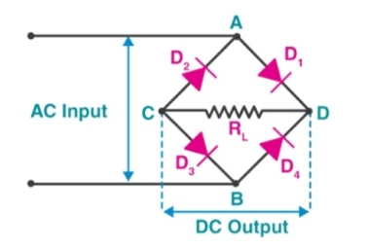
Fig 4.4.4 Rectifier
A junction diode offers a low resistance to current in one direction (when forward biased) and a high resistance in the other direction (when reverse biased).
4.4.5 REGULATOR POWER SUPPLY
A regulator powersupply is an embedded circuit; it converts unregulated AC (Alternating Current) into a constant DC (Direct current). Its function is to supply a stable voltage (or less often current), to a circuit or device that must be operated within certain power supply limits.
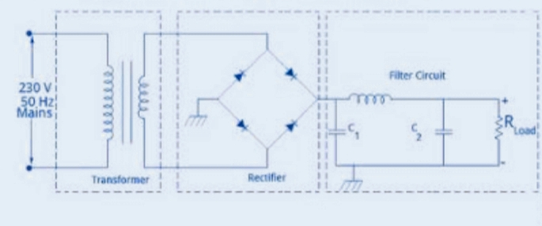
Fig 4.4.5 Regulated Power Supply (Change the diagram its not clear)
4.4.6 LCD
Liquid crystal displays (LCDs) have materials which combine the properties of both liquids and crystals. Rather than having a melting point, they have a temperature range within which the molecules are almost as mobile as they would be in a liquid, but are grouped together in an ordered form similar to a crystal.
An LCD consists of two glass panels, with the liquid crystal material sand witched in between them. The inner surface of the glass plates is coated with transparent electrodes which define the character, symbols or patterns to be displayed polymeric layers are present in between the electrodes and the liquid crystal, which makes the liquid crystal molecules to maintain a defined orientation angle. One each polarizer is pasted outside the two glass panels. This polarizer’s would rotate the light rays passing through them to a definite angle, in a particular direction.By using backlighting, reading is possible in the dark. The LCD’s have long life and a wide operating temperature range. Changing the display size or the layout size is relatively simple which makes the LCD’s more customer friendly.
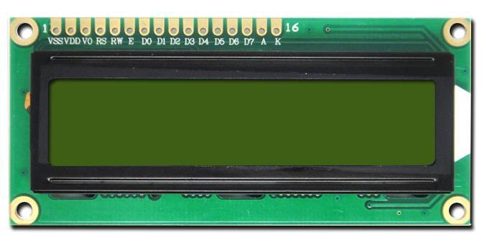

Fig 4.4.6 LCD Module
The command register stores the command instructions given to the LCD. A command is an instruction given to LCD to do a predefined task like initializing it, clearing its screen, setting the cursor position, controlling display etc. The data register stores the data to be displayed on the LCD. The data is the ASCII value of the character to be displayed on the LCD. Click to learn more about internal structure of a LCD.The LCD display used in this project consists of 2 rows. Each row consists of maximum 16 characters. So, using this display only maximum of 32 characters can be displayed.
- Wide viewing angle and high contrast.
- 57 dot character matrix with cursor.
- Interfaces with 4-bit or 8-bit MPUs.
- Displays up to 226 characters and special symbols.
- Low power consumption.
- Custom character patterns are displayed with the character RAM.
- Abundant instruction set including clear display, cursor on/off, and character blinking.
- Compact and light weight for easy assembly to the host instrument.
- Operable on single 5 V power supply.
Check the spacing

4.4.7 RELAY
Relay is also a switch that connects or disconnects two circuits. But instead of manual operation a relay is applied with electrical signal, which in turn connects or disconnects another circuit. Electromechanical relays are frequently used.It converts small electrical stimuli into larger currents. These conversions occur when electrical inputs activate electromagnets to either from or break existing circuits.Relay can be of different types like
- Electromechanical
- solid state
- Reed

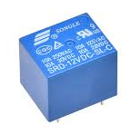
Fig 4.4.7 Relay
They are used to control a circuit by a separate low-power signal or to control several circuits with one signal. When the electromagnet is applied with some current it induces a magnetic field around it.
The collector is attached to the relay coil. Relays are electromechanical devices. There are two types of relays.
- Normally closed
- Normally opened
We are using normally opened type relay. When the controller output from the PC is high the transistor will be in the ON state, so relay is energized. When the controller output from the PC is low the transistor will be in the OFF state, so relay is de-energized the valve will open. When the relay is de-energized the valve will close. So according to the controller output the valve will open or close and thus level is maintained.
4.4.8 RELAY DRIVER
A Relay driver IC is an electromagnetic switch that will be used whenever we want to use a low voltage circuit to switch a light bulb ON and OFF which is connected to 220V mains supply. The required current to run the relay coil is more than can be supplied by various integrated circuits like Op-Amp, etc. they are usually used to regulate current flowing through a circuit or to control other factors such as other components, some devices in the circuit.
The term is often used, for example, for a specialized integrated circuit that controls high-power switches in switched-mode power converters. Now days in market relay driver module is available which combination of relay and a transistor is generally.You will be able to control various appliances, and other equipments with large current. It can be controlled directly by microcontroller. In many modules LED’s is also placed to indicate status of a relay switch.
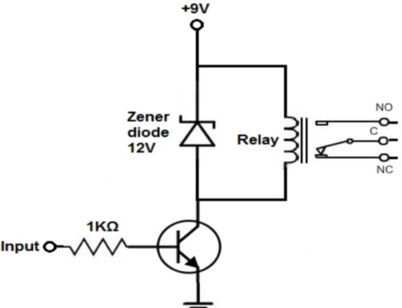
Fig 4.4.8 Relay driver
4.4.9 8051 SERIES MICROCONTROLLER
The complete description regarding the interrupt structure of 8051 is given in ‘INTERRUPTS’ of this manual.
MEMORY ORGANISATION OF 8051
8051 has got separate address spaces for program and data memory.
PROGRAM MEMORY
A program memory is a block of memory which can be used to store a sequence of program codes. It can only be read from and not written into, under normal operating conditions. There can be up to 62k bytes of program memory in 8051. in ROM and EPROM versions of these devices, if the special control signal EA* (External Access enable) to the appendix at the back of this manual for pin details is strapped to Vcc, then program fetches to addresses 000 to 0FFF are directed to the internal ROM. The program fetch will be from external memory, when EA* is grounded.After reset, the CPU begins execution from address location 0000 of the program memory.
DATA MEMORY
Data memory is the Read/Write memory. Hence, it can be both read from and written into 8051 have got 128 bytes of internal data memory and 62k of external data memory.
INTERNAL DATA MEMORY
Internal data memory addresses are one byte wide which includes 128 bytes of on-chip RAM plus a number of special function registers. The 128 bytes of RAM can be accessed either by direct addressing or by indirect addressing.The lowest 32 bytes (00-1F) of on-chip RAM are grouped into 2 banks of 8 register each. Program instructions call out these registers as RO through R7. Bits 3 and 2 in register bank are in use. This allows more efficient use of code space, since register instructions are shorter than instructions that use direct addressing.Reset initializes the stack pointer register to 7 and it is incremented once to start from location 08, which is register R0 of second register bank. Hence, in order to use more than one register bank, the stack pointer should be initialized to a different location of RAM where it is not used for data storage.

EXTERNAL DATA MEMORY
There can be upto 62k bytes of data memory external to the chip. External data memory addresses can be either 1 or 2 bytes wide depending on the addressing mode. The ‘MOVX’ instruction can be used to access the external data memory. External program and data memory may be combined, if desired, by enabling the external memory devices for both RD* and PSEN* cycles.
P3.0  P3.1  P3.2  P3.3  P3.2  P3.5  P3.6  P3.7 | RxD (serial input port)  TxD (Serial output port)  INT0 (External interrupt 0)  INT1 (External interrupt 1)  T0 (Timer/counter 0 external input)  T1 (Timer/counter 1 external input)  WR (External data memory write strobe)  RD (External data memory read strobe)

I/O STRUCTURE OF 8051
PARALLEL PORT
8051 has four 8-bit parallel ports. All four parallel ports are bi-directional. Each line consists of a latch, an output driver and an input buffer.The four ports are named as port 0 (p0), port 1(p1), port 2(p2) and port 3 (p3a). They are bit addressable and has to be represented in the form PX, Y i.e. bit Y of port X while using bit addressing mode. PX.0 is the LSB (Least Significant Bit) of port X and PX.7 is the MSB (Most significant bit) of that port.Out of the four ports, port 0 and port 2 are used in accesses to external memory.
TIMER/COUNTERS
8051 has two 126-bit timer/counters namely Timer / counter 0 and timer / counter 1. They can be configured in any of the four operating modes, which are selected by bit modes 0,1 and 2 are the same for both the timer/counters. Mode 3 is different.
SERIAL PORT:
The 8051 has a full Duplex Serial Port, meaning it can transmit and receive simultaneously received byte has been read from the receive register. The serial port receive and transmit registers are both accessed at special function register SBUF (Serial data Buffer). Writing to SUBF loads the transmit register.
REGSISTERS OF 8051
The various special function registers available in the internal data memory 8051 are listed in Table –2. The table also indicated whether each one is only byte addressable or byte and bit addressable (marked with an asterisk *) and the addresses of those registers (i.e., On-chip RAM address.)
ACCUMULATOR
ACC is the Accumulator register, The mnemonics for Accumulator-Specific instructions, however refer to the Accumulator as simply A. Accumulator is an important Register on which various special operations such as reading from or writing to an external memory , rotation , addition, subtraction, multiplication, division and various other operations can be done.
BREGISTER
Register B is used during multiply and drive operations. For other instructions, it can be treated as another scratch pad register.
STACK POINTER
The stack pointer register is 8 bits wide. It is incremented before data is stored during the execution of PUSH and CALL instructions. While the stack may reside anywhere in the on-chip RAM, the stack pointer is initialized to 07 after a RESET. This causes the stack to begin at location 08.
DATA POINTER
The data pointer (DPTR) consists of a high byte (DPH) and a low byte (DPL). Its intended function is to hold a 16-bit address for external memory access. It may be manipulated as a 16-bit register or as two independent 8-bit registers.
SERIAL DATA BUFFER
The serial data buffer is actually two separate registers, a transmit buffer and a receive buffer register when data is written to SUBF, it goes to the transmit buffer where it is held for serial transmission. When data is read from SBUF, it comes from the receive buffer.
TIMER REGISTERS
Register pairs (TH0, TL0), (TH1, TL1) are the 16-bit counting registers for Timer/counters 0 and 1 respectively.
CONTROL REGISTERS
Special function registers IP, IE, TMOD, TCON, SCON and PCON contain control and status bits for the interrupt system, the Timer/counters and the serial port.
PCON: POWER CONTROL REGISTER
Bit 7 of PCON register is used to control the baud clock generated from the timer. In the case of 80C51BH, PCON register can be used to select the power down mode and idle mode of operation. Please refer to the Intel data sheets of 80C51BH for the complete details of the above said modes. This register is not bit addressable.
4.4.10 THE MAX 232 IC
The MAX-232 IC is used in the RS232 communication system for the conversion of voltage levels on TTL devices that are interfaced with the pc serial port and the microcontroller. This IC is used as a hardware layer converter like to communicate two systems simultaneously.
It converts signals from a TIA-232 serial port to signals suitable for use in TTL-compatible digital logic circuit. The MAX232 is a dual transmitter/dual receiver that typically is used to convert the RX, TX, CTS, and RTS signals.
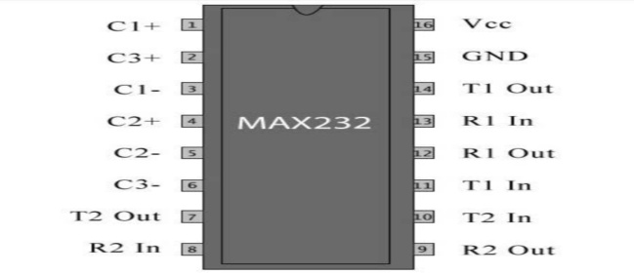
Fig 4.4.10 MAX232 IC
4.4.11 HARDARE DESIGN
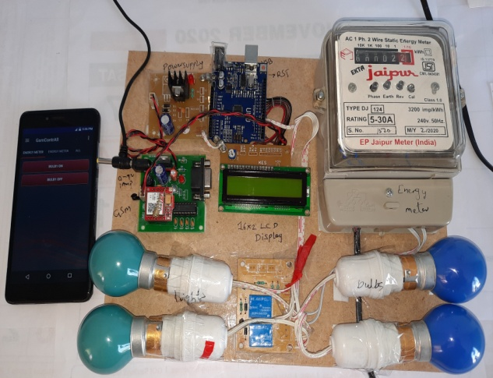
Fig 4.4.11 Hardware Design
4.5 HARDWARE OUTPUT

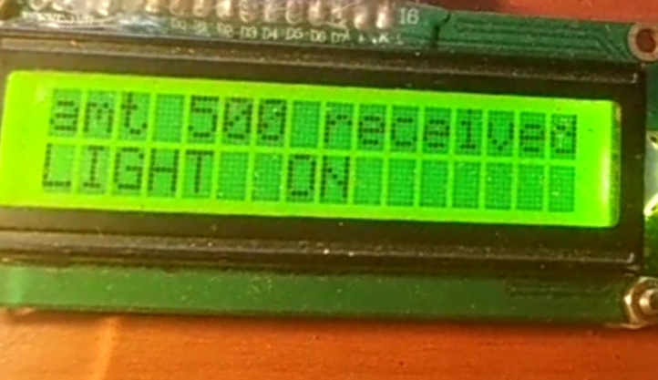
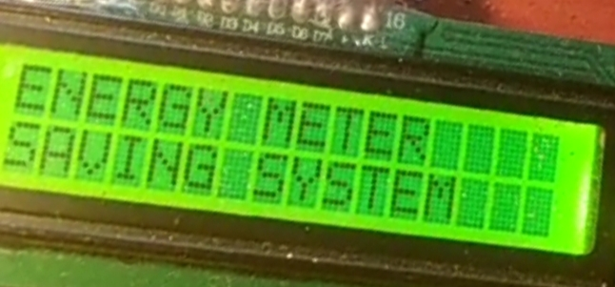

CHAPTER-5
CONCLUSION
The proposed system for energy meter billing is automatic without human intervention and consumer can directly know the amount has to pay. The electricity board can disconnect or reconnect the connection from remote place through the LTE modem. If the units consumed by the user crosses certain utilization of the power automatically switch off the load connected to it. So that we can reduce the wastage of power in the households etc. It allows users to purchase the reload card easily without travel for a long distance. Utility companies can make their own prepaid energy meter to lower its production cost. Hence, the initial installation fee is lower for the consumers that want to install. For decade, conventional energy meter has been used widely in the household. It is cheaper in term of initial cost, but it suffers from the meter accuracy, human error and billing experience. In this project, the prototype of the smart meter is integrating the GSM prepaid system and the over current protection relay. It is an all-in-one device that integrates the billing experience and safety feature inside a small box. With this smart meter, users can replace the old fuse protection with the relay. The relay can reset automatically countless time without replacing a newone. On the other hand, fuse needed to replace every time one it blows off. The digitally programmed overcurrent relay can set the current limit based on individual consumer demand. Prepaid energy meter is very suitable and feasible for the rural area housing. Prepaid systems will reduce the incidence of inaccurate meter readings due to natural ageing, installation errors or deliberate tampering. The prepayment system will give users a better appreciation of power utilization and reduce the numbers of arrears, usually happen in the rural area.
REFERENCES
[1] Vivek Kumar Sehgal and Nitesh Panda, NipunRaiHanda, Shubhrangshu Naval and VipulGoel, “Electronic Energy Meter With Instant Billing” Waknaghat , Solan @ UKSim Fourth European Modelling Symposium on Computer Modelling and Simulation © 2010 IEEE .

[2] K. Jack and G. Smith, ‘‘The Impact of Prepaid Electricity Meters on Low-Income Households in South Africa,” 2015.

[3] O. Adeolu and O. Mayowa Emmanuel, ‘‘Design of SMS Prepaid Energy Meter for a Cashless Economy with Recharge Option and Bypass,” Am. J. Eng. Res., no. 56, pp. 2320–847, 2016.

[4] M. Razif, ‘‘Prepaid Energy Meters – ‘Electrifying’ Prospects,” Frost Sullivan,2004. [Online]. Available: http://www.frost.com/sublib/display-marketinsight. do?id=27962688. [Accessed: 12-May-2018].

[5] S. A. Joshi, S. Kolvekar, Y. R. Raj, S. Singh, “IoT Based Smart Energy Meter”, International Journal of Research in Communication Engineering, Vol. 6, 2016.

[6] Gobhinath S, Gunasundari N, Gowthami P, “Internet of Things (IOT) Based Energy Meter”,International Research Journal of Engineering and Technology (IRJET), Vol. 3(4), 2016.

[7] Win AdiyansyahIndra, Fatimah BtMorad, NorfadzliaBintiMohdYusof and SitiAsmaChe Aziz, “GSM-Based Smart Energy Meter with Arduino Uno”, International Journal of Applied Engineering Research, Vol. 13, No. 6, pp. 3948-3953, 2018.

[8] VipulDeshbhratar, “Smart Energy Metering with Realtime Power Analysis and Auto Monthly Billing”, May 2019.

[9] Geno Peter , Samat Bin Iderus, ‘‘Design of enhanced energy meter using GSM prepaid system and protective relays ”, August 2020.

